ELECTRONIC SUPPLEMENTARY INFORMATION 5

ESM 5

Figure S5 - The role of harvest model in driving in driving the probability of crossing a tipping point (A), and Net Present Value (NPV) (B), and # rescues (C). Measurement precision (increases in x axis) or maximum harvest rate (increases in y axis) can increase the probability of crossing a tipping point and decrease the NPV of a given population. Switching the harvest limit from 0.25 Bmsy to Bmsy decreases the risk of tipping and NPV slightly

We consider two different harvest models, the biomass limit for harvest is at bmsy (Blim=Bmsy) and the biomass limit for harvest is at 0.25 Bmsy, or for cases where A> 0.

Here are visualizations two models we considered

Blim = Bmsy Blim = 0.25Bmsy

Blim = Bmsy
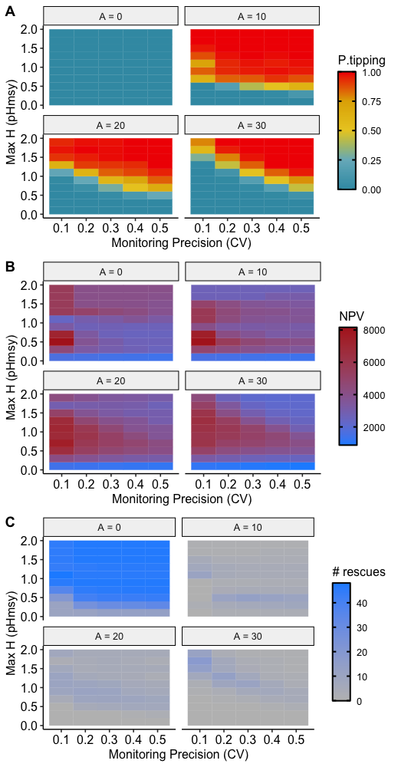

Harvest model Blim = 0.25Bmsy



